1. **Filtering with the Slicer Tool**

**slicers** is a quick and effective way to filter your data. Slicers can be inserted for each of the fields that you want to filter. Slicer will have buttons denoting the values of the field that it represents. You can click on the buttons of a slicer to select/ unselect the values in the field.

To understand the usage of slicers,

**consider the example** of **sales data** region-wise, month wise and salesperson-wise.

Assume you have the following PivotTable with this data.

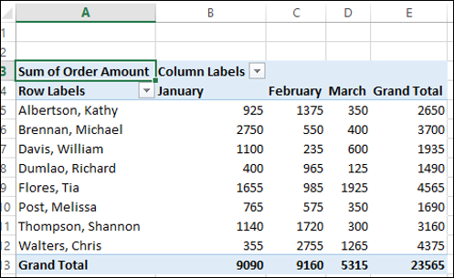

## Inserting Slicers

Suppose you want to filter this PivotTable based on the fields – Region and Month.

* Click on ANALYZE under PIVOTTABLE TOOLS on the Ribbon.
* Click on Insert Slicer in the Filter group. The Insert Slicers dialog box appears. It contains all the fields from your data table.
* Check the boxes Region and Month.
* Click OK.

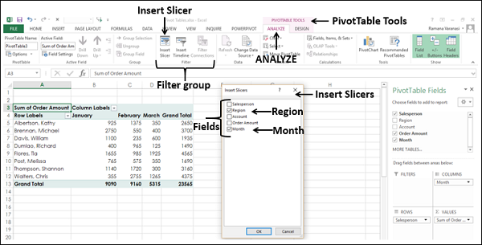

Slicers for each of the selected fields appear with all the values selected by default. Slicer Tools appear on the Ribbon to work on the Slicer settings, look and feel.

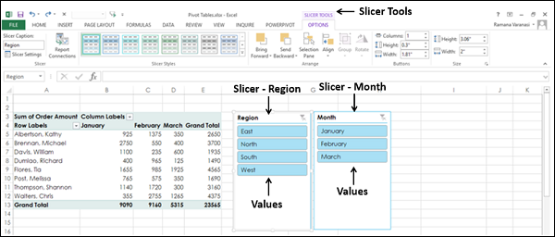

## Filtering with Slicers

As you can observe, each slicer has all the values of the field that it represents and the values are displayed as buttons. By default, all the values of a field are selected and hence all the buttons are highlighted.

Suppose you want to display the PivotTable only for the regions South and West and for the Months February and March.

* Click on South in the Slicer for Region. Only South will be highlighted in the Slicer – Region.
* Keep Ctrl key pressed and click on West in the Slicer for Region.
* Click on February in the Slicer for Month.
* Keep Ctrl key pressed and click on March in the Slicer for Month.

Selected items in the Slicers are highlighted. PivotTable with summarized values for the selected items will be displayed.

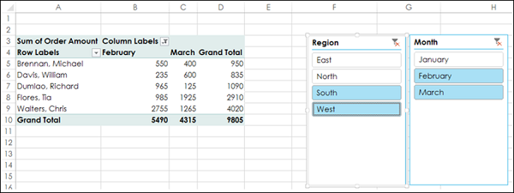

To add/remove values of a field from the filter, keep the Ctrl key pressed and click on those buttons in the slicer of the field.

Select **Clear Filter** Delete to clear the slicer filter.

1. **Using the Freeze Panes Tool**

The[**Excel**](https://www.simplilearn.com/tutorials/excel-tutorial/excel-dashboard) **Freeze Panes option** allows you to lock your columns and/or rows so that when you scroll down or over to view the rest of your sheet, the column and/or row will remain on the screen.

## Freeze rows or columns

**Freeze the first column**

* Select **View** > **Freeze Panes** > **Freeze First Column**.

The faint line that appears between Column A and B shows that the first column is frozen.

**Freeze the first two columns**

1. Select the third column.
2. Select **View** > **Freeze Panes** > **Freeze Panes.**

**Freeze columns and rows**

1. Select the cell below the rows and to the right of the columns you want to keep visible when you scroll.
2. Select **View** > **Freeze Panes** > **Freeze Panes.**

## Unfreeze rows or columns

* On the **View** tab > **Window** > **Unfreeze Panes**.  
  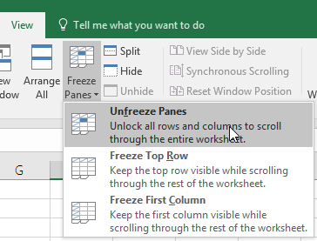

1. **Grouping Data (Columns and/or Rows)**

Here are the steps to follow to group rows:

1. Select the rows you wish to add grouping to (entire rows, not just individual cells)
2. Go to the Data Ribbon
3. Select Group
4. Select Group again

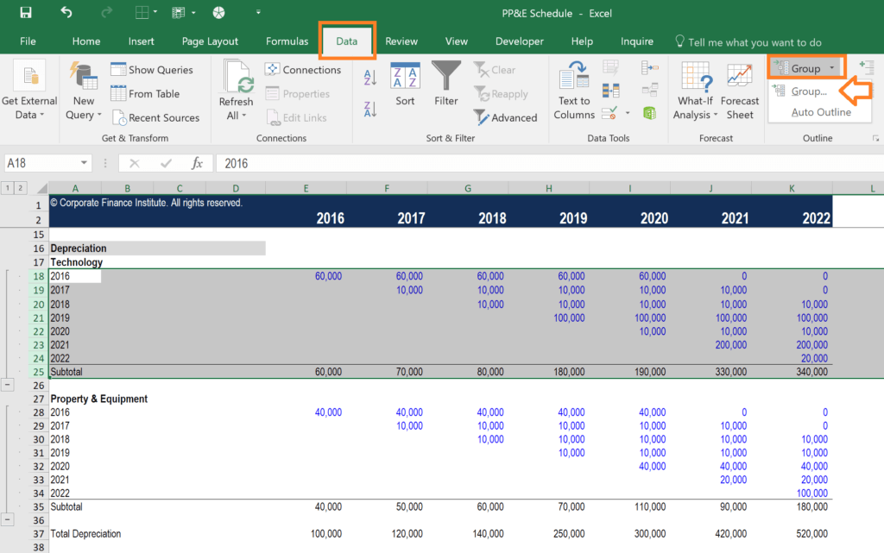

You can repeat the steps above as many times as you like, and you can also apply it to columns as well.

Once you’re finished, you can press the “-” buttons in the margin to collapse the rows or columns.

If you want to expand them again, press the “+” buttons in the margin, as shown in the screenshot below.

There is also a “1” button in the top left corner to collapse all groups, and a “2” button to expand all groups.

**Reasons to use the Excel Group:**

* To easily expand and contract sections of a worksheet
* To minimize schedules or side calculations that other users might not need
* To keep information organized
* As a substitute for creating new sheets (tabs)

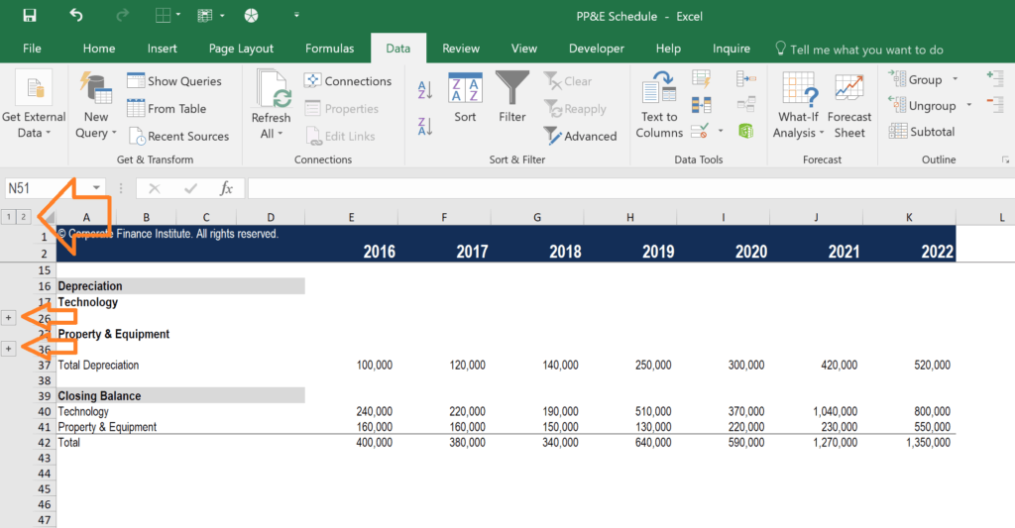

1. **Print Options for Large Sets of Data**

the process for formatting a sheet to print is really pretty straightforward:

1. Setting the Print Area and Print Titles
2. Inserting Headers and Footers
3. Controlling Margins, Page Orientation, and Page Size
4. Inserting/Adjusting Page Breaks
5. Previewing the final result and tweaking where necessary

### **Setting the Print Area and Print Titles**

**EXAMPLE: sheet**

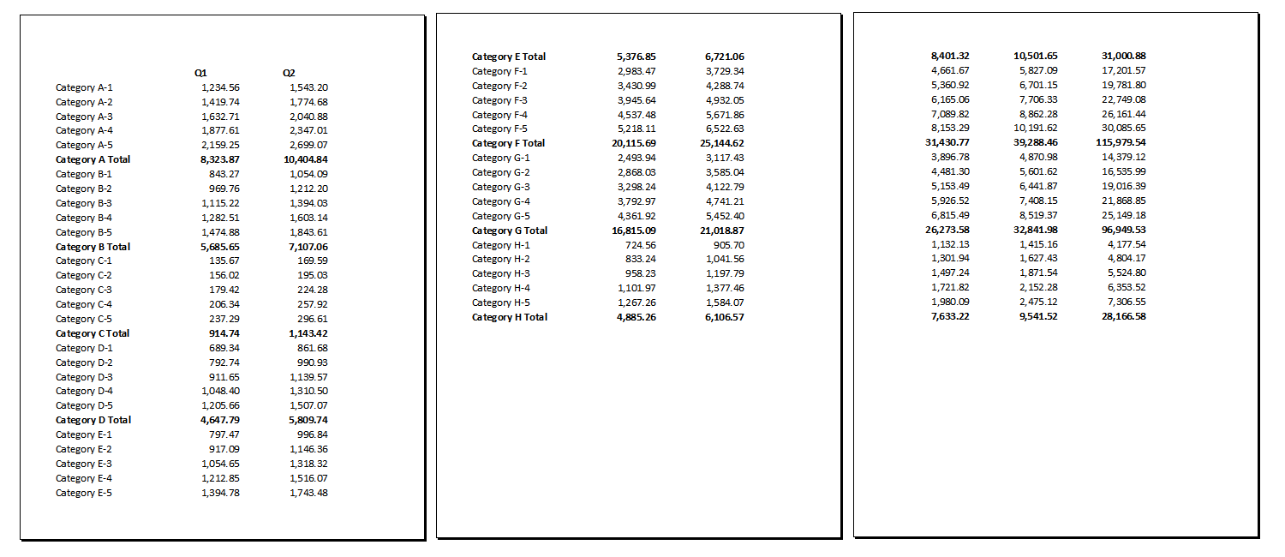

**Printout 1: Pages 1, 2 and 4 of an Excel printout (click to enlarge)**

If you look closely at these Print Preview images, page 1 is fine – you can see the column labels and the row labels (with the category names) on the left.

But then page 2 is missing the column labels, and if you look at page 4, *none* of that is carried over that far into the printout. So, unless you’re planning on taping together your spreadsheet into one big piece of paper, you’re going to have a hard time figuring out which numbers go with each quarter/category.

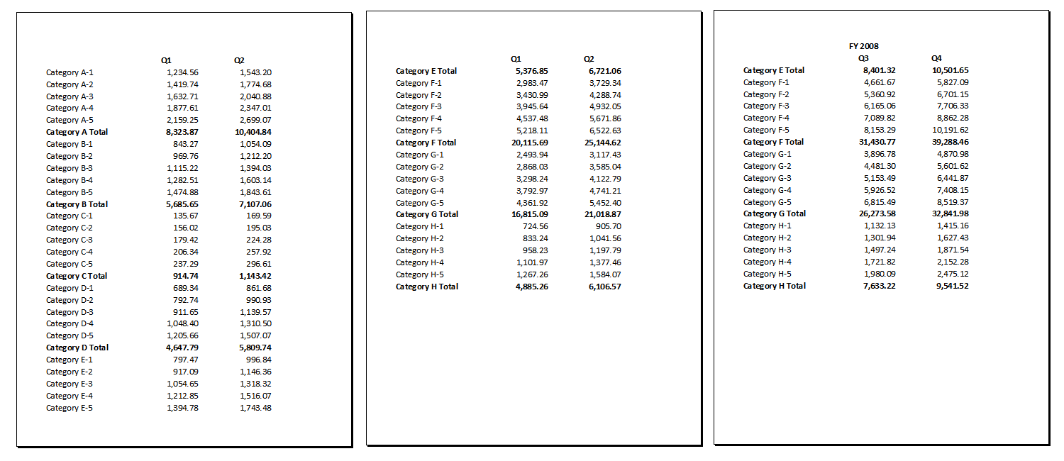

Printout 2: Pages 1, 2 & 4 from **printout with changes (click to enlarge)**

The difference here is that I’ve defined the print area as all of the numbers (from cell B3 to AE50) and the print titles as rows 1 and 2 and column A by going into the **Page Setup dialog box from the Page Layout tab**, then selecting the Sheet tab:

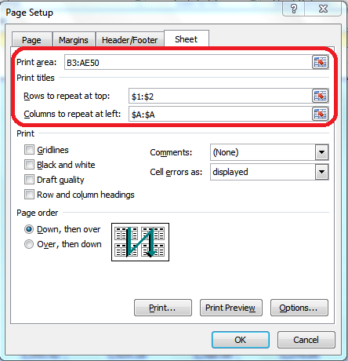

That’s what enables the row and column labels to print on *every page*.

### **Inserting Headers & Footers**

For example, you can insert a custom title at the top and page numbers at the bottom by clicking the Custom Header and Custom Footer buttons:

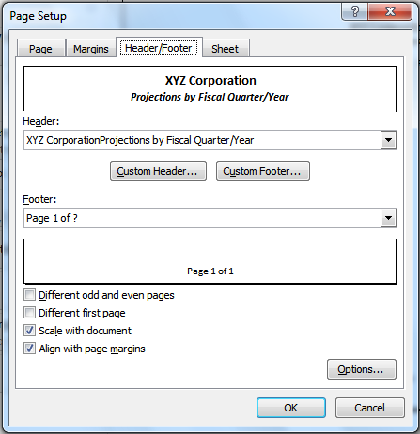

### Controlling margins, orientation and page size

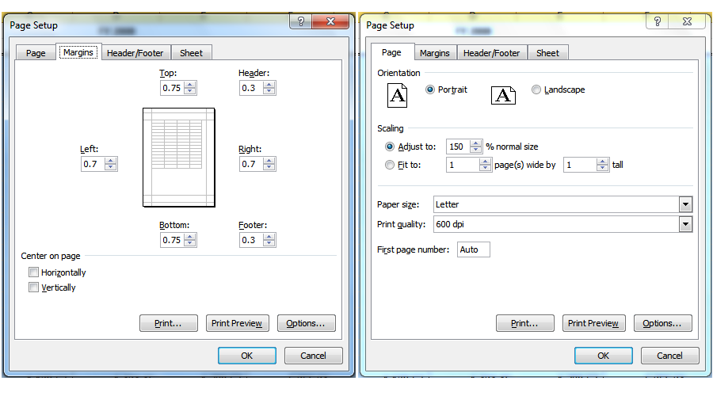

As you can see from above, you can adjust the placement of the headers and footers and the page margins on the Margins tab, and control the orientation (portrait versus landscape) and the page size (letter, legal, ledger, A4, etc.) on the Page tab.

One more thing: if printing gridlines on your sheet would help improve readability

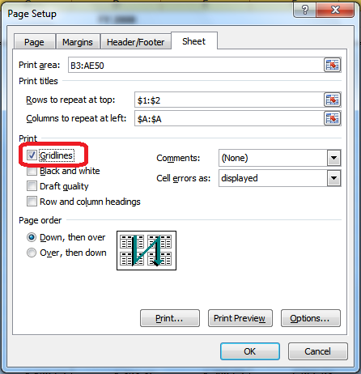

you can click Print Preview to check your progress.

### **Inserting and adjusting page breaks**

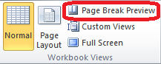

The easiest way to deal with page breaks in Microsoft Excel is in Page Break Preview mode. Go to the View tab on your ribbon and click Page Break Preview.

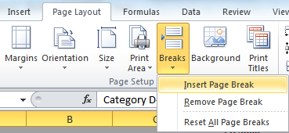

If you make a mistake in where you insert your page break, simply drag the page break to the right spot (since you’re in Page Break Preview mode anyway).

### **Previewing and adjusting the final print result**

You can also make adjustments *directly* in Print Preview:

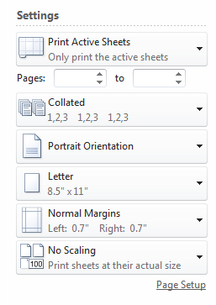

The above menu appears directly to the left of the preview of your document.

## **The final result**

**After all that, here’s how the sample spreadsheet finally prints:**

